| **“MACHINE LEARNING TECHNIQUES FOR ACOUSTIC EMISSION BASED MONITORING OF HIP IMPLANTS”** |
| --- |
| **By** |
| **SHAUN NORONHA 4NM20IS132**  **SHEETAL 4NM20IS134**  **RITESH SHETTY 4NM20IS136**  **SHREENIDHI 4NM20IS138** |
|  |
| **BACHELOR OF ENGINEERING** |
| **IN** |
| **INFORMATION SCIENCE & ENGINEERING** |
|  |
| **Under the guidance of** |
| **Dr. Manjula Gururaj Rao Dr. Rashmi P Shetty** |
| **Associate Professor Assistant Professor Gd-III** |
|  |
| ***Project – Phase I Report Submitted to NMAM Institute of Technology, Nitte. An***  ***Autonomous Institution affiliated to VTU Belagavi*** |
| **DEPARTMENT OF INFORMATION SCIENCE & ENGINEERING** |

**

ISO 9001:2015 Certified

Accredited with ‘A’ Grade by NAAC



*Department of* ***Information Science & Engineering***

CERTIFICATE

Certified that the Phase I of the project work entitled **“ MACHINE LEARNING TECHNIQUES FOR ACOUSTIC EMISSION BASED MONITORING OF HIP IMPLANTS”** carried out by **SHAUN NORONHA (4NM20IS132), SHEETAL (4NM20IS134), RITESH SHETTY (4NM20IS136), SHREENIDHI (4NM20IS138)**, are bonafide students of **NMAM Institute of Technology**, **Nitte** have been carried out satisfactorily. The Project – Phase I report has been prepared as per the prescribed format.

**Name & Signature of Guide Name & Signature of Project Coordinator**

**Name & Signature of HOD**

**Project – Part I Evaluation**

**Name of the Examiners** **Signature with Date**

*1. _______________________________ ________________________________*

*2. _______________________________ ________________________________*

*3. _______________________________ ________________________________*

*4. _______________________________ ________________________________*

**LIST OF CONTENTS**

| **Acknowledgement** | | | | **i** |
| --- | --- | --- | --- | --- |
| **Abstract** | | | | **ii** |
| **Chapters** | | | | **iii** |
| **List of Figures** | | | | **v** |
| **List of Tables** | | | | **vi** |
| **CHAPTERS** | | | | **PageNo** |
| **1. INTRODUCTION** | | | | **1** |
|  | 1.1 | Monitoring Of Hip Implants | | **1** |
|  | 1.2 | Machine Learning | | **2** |
|  | 1.3 | Literature Review | | **3** |
|  | 1.4 | Problem Statement & Objectives | | **4** |
| **2. EXPERIMENTAL SETUP** | | | | **3** |
|  | 2.1 | Acoustic Emission Setup | | 3 |
|  | 2.2 | Corrosion Setup | | 5 |
| **3. MACHINE LEARNING TECHNIQUES** | | | | 7 |
|  | 3.1 | Methodology | | 7 |
|  | 3.2 | Multi-Layer Perceptron Model | |  |
|  | 3.3 | Recurrent Neural Network Model | |  |
| **4. MODEL DEVELOPMENT** | | | | 8 |
|  | 4.1 | Identifying anomalies | | 8 |
|  | 4.2 | Data Preprocessing | |  |
|  | 4.3 | Architecture | |  |
|  |  | 4.3.1 | Multi-Layer Perceptron Model |  |
|  |  | 4.3.2 | Recurrent Neural Network Model |  |
| **5. IMPLEMENTATION** | | | | 9 |
|  | 5.1 | Code/pseudocode | | 9 |
|  | 5.2 | Data Flow Diagrams/flowcharts | | 9 |
|  | 5.3 | Explanation of the each code | | 9 |
| **6. RESULTS AND DISCUSSION** | | | | 14 |
|  | 6.1 | Results of MLP model implementation | | 14 |
|  | 6.2 | Results of RNN model implementation | |  |
|  | 6.2 | Graphs depicting the output | | 15 |
| **7. CONCLUSION AND FUTURE ENHANCEMENT** | | | | 16 |
|  | 7.1 | Limitations of the project | | 16 |
|  | 7.2 | Future Enhancements | | 16 |
| **REFERENCES** | | | | 17 |

**LIST OF FIGURES**

| **Figure No.** | **Title of Figures** | **Page No.** |
| --- | --- | --- |
| 1 | The effect of arthritis on the normal function of a hip joint | 2 |
| 2.1 | Potential use of the acoustic emission sensors to monitor THR performance and failure process | 4 |
| 2.2 | Example of radiographs (drawings) that can be given as input to the ML model for implant detection | 6 |
| 2.3 | Understanding implant failures from a radiograph | 6 |
| 5 | Accuracy and Loss Graphs | 14 |
| 6 | Correlation matrix | 15 |
| 7 | Confusion Matrix | 15 |
| 8 | Actual vs Predicted Data | 15 |

**ACKNOWLEDGEMENT**

Any achievement, be it scholastic or otherwise does not depend solely on the individual efforts but on the guidance, encouragement and cooperation of intellectuals, elders and friends. A number of personalities, in their own capacities have helped me in carrying out this project work. We would like to take this opportunity to thank them all.

First and foremost we would like to thank **Dr. Niranjan N Chiplunkar**, Principal, NMAMIT, Nitte, for his moral support towards completing my seminar work.

We would like to thank **Dr. ASHWINI B**, Head of the Department, Information Science & Engineering, NMAMIT, Nitte, for her valuable suggestions and expert advice.

We also extend our cordial thanks to Project Coordinators, **Mr. Vasudev Pai** & **Dr. Manjula Gururaj Rao** for their support and guidance.

We extend my heartfelt appreciation to our guide, **Dr. P Srinivasa Pai, a distinguished PhD holder in Mechanical Engineering and the Head of the Department of Mechanical Engineering** at NMAM Institute of Technology, Nitte, 574110, India. Additionally, we would like to express our sincere gratitude to our guide, **Dr. Mathew T Mathew, a PhD holder in Mechanical Engineering and an Associate Professor in the Department of Biomedical Science at UIC School of Medicine, Rockford, IL, US.** Dr. Mathew leads the **Regenerative Medicine and Disability Lab at UIC Rockford**. Both guides have been invaluable sources of guidance, consistent encouragement, and unwavering assistance throughout the course of this project.

We deeply express my sincere gratitude to our guide **Dr. Manjula Gururaj Rao, Associate Professor,** Department of ISE, NMAMIT, Nitte, and our co-guide **Dr. Rashmi P Shetty, Assistant Professor Gd-III** for their able guidance, regular source of encouragement and assistance throughout this project

We thank my Parents, and all the Faculty members of the Department of Information Science & Engineering for their constant support and encouragement.

Last, but not the least, we would like to thank my peers and friends who provided us with valuable suggestions to improve our project.

**ABSTRACT**

Hip implant monitoring is critical for ensuring the longevity and functionality of prosthetic devices, but traditional methods often lack real-time insights into the implant's condition. This project addresses the challenge of effective hip implant monitoring by leveraging acoustic emission (AE) signals, which provide valuable information about the structural integrity and wear of the implant components.

The approach adopted in this study involves the application of machine learning techniques to analyze and interpret the acoustic emission data generated by hip implants during daily activities. Our aim is to develop a deep learning model that learns the acoustic emission patterns and classifies the current health of the implant. This approach enables the identification of subtle changes and anomalies that may indicate early signs of implant deterioration, providing a proactive and predictive monitoring solution.

The proposed solution enhances the current state of hip implant monitoring by offering a more nuanced and accurate assessment of implant performance. The machine learning models employed in this study exhibit high sensitivity to subtle changes in the acoustic emission patterns, allowing for early detection of potential issues. This proactive monitoring approach not only contributes to the overall reliability of hip implants but also enables timely interventions, reducing the likelihood of complications and the need for extensive corrective procedures. The outcomes of this project has a significant implication for improving the long-term success of hip implant surgeries, enhancing patient outcomes, and reducing the economic burden associated with implant-related complications.

1. **INTRODUCTION**

Acoustic Emission (AE) monitoring, capturing stress waves from rapid energy release in materials, is crucial for assessing the structural integrity of hip implants. By analyzing these emissions, surgeons can gain valuable insight into the condition of the joint and make more informed decisions about the surgical procedure. During a hip surgery, sensors are placed on the patient's skin to capture the acoustic emissions generated by the joint. The signals are then processed by a computer and displayed on a screen for the surgeon to interpret. This technology allows for real-time monitoring of the joint during the surgery, which can improve accuracy and reduce the risk of complications.

**1.1 Monitoring Of Hip Implants**

The integration of advanced technologies, particularly acoustic emission (AE) and machine learning (ML) techniques, has revolutionized the monitoring of hip implants. AE, a non-destructive and non-intrusive method, provides real-time insights into the structural integrity of hip implants during daily activities. It effectively detects active damage mechanisms such as crack growth, delamination, and wear, making it invaluable for assessing implant conditions in total hip replacement (THR) surgeries. The study emphasizes the significance of AE, particularly in identifying early signs of implant deterioration, such as fretting-corrosion at the modular junction interface.

The application of ML techniques further enhances the monitoring process by analyzing and interpreting complex AE data. ML algorithms, including supervised and unsupervised learning, classify normal and abnormal AE patterns, enabling early detection of subtle changes that may indicate potential issues. This proactive approach allows for timely interventions and reduces the risks associated with complications. By merging engineering, healthcare, and data science, the combination of AE and ML offers a promising interdisciplinary approach to improve the long-term success of hip replacement surgeries, enhance patient outcomes, and alleviate the economic burden associated with implant-related complications.

**1.2 Machine Learning**

Machine learning (ML) has revolutionized hip implant monitoring by providing sophisticated tools for analyzing and interpreting acoustic emission (AE) data. ML models can effectively decipher complex patterns within the large datasets generated by hip implants during daily activities. Supervised learning models, such as classification algorithms, differentiate between normal and abnormal AE patterns, enabling early detection of potential issues and proactive intervention by healthcare professionals.

Machine Learning (ML) techniques offer a powerful means of deciphering complex AE data, providing timely detection of potential issues. Hip implants are vital for individuals post-hip replacement surgery. Monitoring AE helps identify early signs of wear, degradation, or structural changes, ensuring the implants' long-term functionality. AE data is collected through sensors on or near the hip implant, recording acoustic signals during weight-bearing activities like walking. The complexity and noise in this data require advanced analytical approaches. AE data's complexity and noise make manual analysis challenging. Traditional methods may struggle, necessitating advanced techniques for effective processing and extraction of meaningful insights.

Unsupervised learning techniques, such as clustering algorithms, uncover hidden insights within the AE data without predefined labels. This approach is valuable for identifying subtle changes or anomalies that may not be apparent through traditional analysis methods. Deep learning models, particularly recurrent neural networks (RNNs) or long short-term memory networks (LSTMs), capture temporal dependencies in the AE signals and excel at recognizing sequential patterns. This makes them well-suited for monitoring dynamic changes in the acoustic emission data over time.

The choice of ML model depends on the specific goals of the hip implant monitoring system. Classification models are effective for binary categorization of normal and abnormal states, while clustering and deep learning models provide more nuanced insights into the temporal dynamics and complex relationships within the AE data. By leveraging a diverse set of ML techniques, the monitoring system can offer a comprehensive and accurate assessment of hip implant conditions, ultimately contributing to the success of total hip replacement surgeries and improving patient well-being.

ML-based AE monitoring systems can integrate seamlessly into existing healthcare infrastructures. This integration fosters collaboration between healthcare professionals and technology, improving patient outcomes. The integration of ML with AE-based monitoring enhances early detection, predictive maintenance, and overall reliability of hip implants. This interdisciplinary approach, combining engineering, healthcare, and data science, ensures the success of hip replacement surgeries and improves patient outcomes.

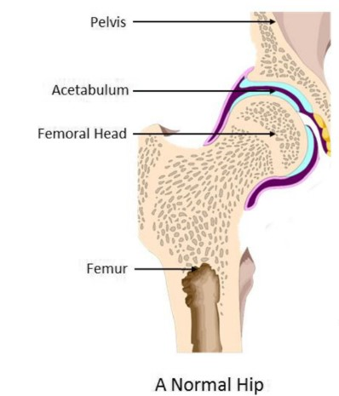 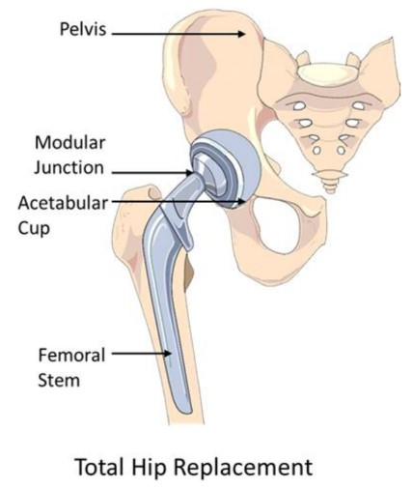

*Fig 1: The effect of arthritis on the normal function of a hip joint*

**1.3 LITERATURE SURVEY**

Research on the application of Acoustic Emission (AE) monitoring for hip implants has evolved from recognizing its potential in biomedical settings to a more recent focus on integrating Machine Learning (ML) techniques. Early studies explored fundamental principles of AE, emphasizing its relevance for detecting structural changes in implant materials. Traditional signal processing techniques were initially employed for AE data analysis, but limitations in handling complexity and noise paved the way for the adoption of ML.

**1.3.1 Overview of Base Paper 1:**

The focal point of this literature review is the seminal work titled **"Hip Implant Performance Prediction by Acoustic Emission Techniques: A Review," authored by Ampadi R. Remya, B. Vishwash, Christine Lee, P. Srinivasa Pai, Alejandro A. Espinoza Oras, Didem Ozevin, and Mathew T. Mathew.** This substantial contribution, published in the International Federation for Medical and Biological Engineering in 2020, serves as the cornerstone for our examination of acoustic emission (AE) techniques in predicting the performance of hip implants.

**1.3.1.1 Review**

The selected paper provides a comprehensive overview of AE techniques applied to the monitoring of hip implants, with a particular emphasis on their role in the early detection of wear, degradation, and structural changes. The primary objective is to ensure the longevity and reliability of total hip replacement surgeries. This section offers a contextual introduction to the foundational aspects explored in the paper.

**1.3.1.2 Application of Acoustic Emission in Hip Implant Monitoring**

An extensive exploration of the paper's content reveals a focused discussion on the application of both supervised and unsupervised machine learning (ML) methods in the classification of AE patterns. The incorporation of ML techniques signals a progressive shift toward data-driven approaches for interpreting acoustic signals, providing a nuanced understanding of hip implant performance. This subsection delves into the significance of ML methodologies within the context of AE and hip implant monitoring.

**1.3.1.3 Importance of Feature Extraction and Selection**

Critical to the paper's discourse is the emphasis on feature extraction and selection strategies, elucidating their vital role in optimizing the performance of ML models. This consideration underscores the necessity of identifying informative aspects within raw AE data, ensuring that ML algorithms effectively discern pertinent patterns associated with the health and integrity of hip implants. This section elucidates the pivotal role of feature extraction and selection in enhancing the precision of machine learning models.

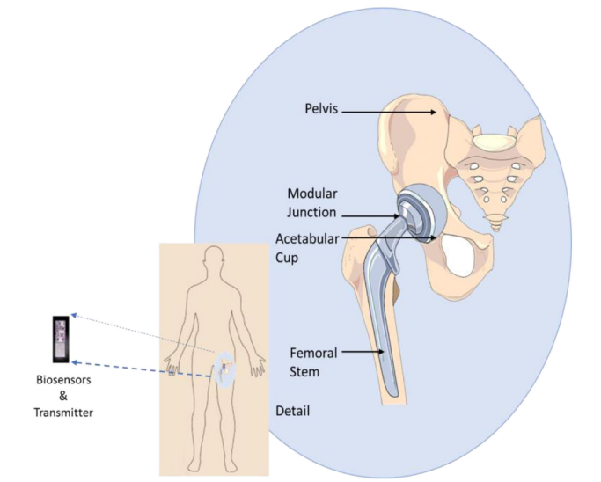

*Fig 2.1 : Potential use of the acoustic emission sensors to monitor THR performance and failure process*

**1.3.1.4 Results and Key Findings**

The literature review culminates in a synthesis of the key findings from the selected paper, summarizing its contributions to the understanding of AE techniques and machine learning methodologies in the realm of hip implant monitoring. This subsection encapsulates the essence of the paper's outcomes and their implications for advancing predictive techniques in the field of orthopedic implant diagnostics.

In summation, the selected paper serves as a foundational piece in comprehensively reviewing the utilization of AE techniques and machine learning methodologies for hip implant monitoring. It offers valuable insights into early detection and prediction of potential issues in this critical biomedical context, providing a solid framework for further research and advancements.

**1.3.2 Overview of Base Paper 2:**

The research paper entitled **"Artificial Intelligence and Machine Learning as a Viable Solution for Hip Implant Failure Diagnosis—Review of Literature and In Vitro Case Study," authored by Remya Ampadi Ramachandran, Sheng‑Wei Chi, P. Srinivasa Pai, Kharma Foucher, Didem Ozevin, and Mathew T. Mathew,** was published in the International Federation for Medical and Biological Engineering in 2023.

**1.3.2.1 Review:**

This section of the paper provides a thorough examination of the existing literature concerning the application of artificial intelligence (AI) and machine learning (ML) in the context of diagnosing hip implant failure. The authors meticulously explore the current research landscape, emphasizing advancements in utilizing AI and ML methodologies to enhance diagnostic capabilities associated with hip implant performance.

**1.3.2.2 Methodology:**

The paper delves into the methodologies employed in the literature under review, offering insights into how AI and ML techniques are integrated for improving the accuracy, efficiency, and early detection of potential issues with hip implants. This section lays the groundwork for understanding the practical applications of these technologies in the diagnosis of hip implant failure.

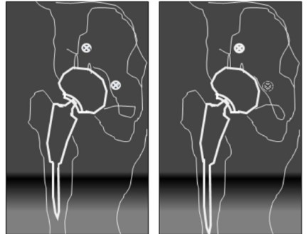 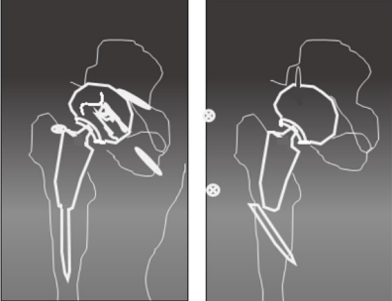

*Fig 2.2 : Example of radiographs that can be given Fig 2.3 : Understanding implant failures from*

*as input to the ML model for implant detection a radiograph*

**1.3.2.3 In Vitro Case Study:**

A pivotal aspect of the paper is the inclusion of an in vitro case study, conducted to provide tangible insights into the application of AI and ML in a controlled laboratory setting. This section presents the results of the case study, highlighting the practical implications and effectiveness of utilizing advanced technologies for diagnosing hip implant failure.

**1.3.2.4 Results and Findings:**

The authors summarize the key results and findings derived from the literature review and the in vitro case study. This section offers a consolidated overview of the contributions made by AI and ML in enhancing the diagnostic capabilities associated with hip implant performance.

**1.3.2.5 Conclusion:**

The paper concludes by summarizing its contributions, emphasizing the interdisciplinary nature of the research, and positioning itself as a pivotal reference for researchers, clinicians, and industry professionals. The comprehensive overview, detailed methodology, and tangible results make this paper a valuable resource for advancing the frontier of orthopedic implant diagnostics.

**1.4 PROBLEM STATEMENT & OBJECTIVES**

To develop a machine learning model that can use acoustic emission to determine the status of the hip joints, and to use machine learning techniques to analyze predictive maintenance of the hip joint problems.

**Objectives of the Project:**

1. To perform the pre-processing of the available data.

2. Train machine learning algorithms to detect and classify abnormal acoustic patterns associated with potential issues in hip transplants.

3. Implement predictive maintenance models using AI/ML to anticipate potential failures or complications in hip transplants based on acoustic emission patterns.

4. Identify and differentiate normal acoustic signatures from abnormal ones to detect early signs of implant failure or complications.

**2. EXPERIMENTAL SETUP**

**2.1 ACOUSTIC EMISSION SETUP**

**DATA COLLECTION PROCEDURES**

The crucial task of gathering data for the development of Machine Learning (ML) models will be undertaken at the Department of Biomedical Science, University of Illinois Chicago College of Medicine (UICOM-R) in Rockford, IL, USA. The experimental setup employed for data acquisition involves an in vitro hip simulator, meticulously designed to investigate tribocorrosion processes associated with hip implants. The schematic diagram of the hip implant simulator, depicted in Figure 3, illustrates the intricacies of the experimental apparatus, incorporating both mechanical and electrochemical components.

**2.1 In Vitro Hip Simulator**

The in vitro hip simulator serves as the foundation for data collection, adopting either a pin-on-ball or head-cup interface model. This simulator, as showcased in Figure 3, has been meticulously designed to emulate the conditions relevant to hip implant scenarios. The mechanical, electrochemical, and acoustic emission data acquisition systems are integrated into the simulator, offering a comprehensive approach to capturing vital information during simulated hip joint movements.

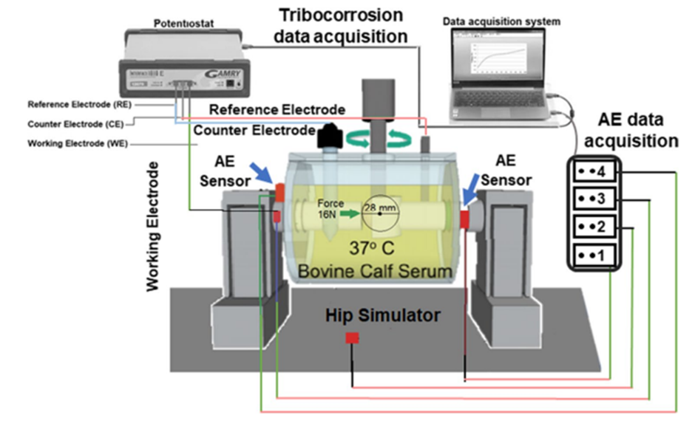

**2.2 Acoustic Emission (AE) Data Collection**

The AE data is procured through strategically positioned AE sensors within the hip simulator setup. These sensors capture stress waves released during the tribocorrosion processes. The acquired AE data is pivotal for understanding the acoustic signals indicative of wear, degradation, or structural changes in the hip implant. This data will serve as the foundation for training the ML models.

**2.3 Tribocorrosion Data Collection**

Tribocorrosion data, essential for comprehending the interplay between mechanical wear and electrochemical processes, is acquired through the Gamry Echem Analyst tool. This tool is integrated into the hip simulator, allowing for the simultaneous collection of tribocorrosion data along with AE signals. The tribocorrosion data encompasses mechanical and electrochemical parameters critical for a holistic understanding of the implant's performance.

**2.4 Experimental Framework and Citation**

The experimental framework for tribocorrosion investigations draws upon the methodology outlined in the work of Rodrigues where biomechanical simulations of temporomandibular joint replacement devices were conducted using the finite element method. This scoping review provides a foundation for adapting finite element methods to the study of tribocorrosion in hip implants. The citation of Rodrigues adds a scholarly dimension to the chosen experimental approach, aligning it with established biomechanical simulation methodologies.

The data collection procedures outlined involve the utilization of a sophisticated in vitro hip simulator, integrating AE sensors and the Gamry Echem Analyst tool. This setup enables the concurrent acquisition of acoustic emission and tribocorrosion data, laying the groundwork for the development of ML models. The citation of Rodrigues further contextualizes the experimental approach within the established biomechanical simulation domain.

**3. MACHINE LEARNING TECHNIQUES**

**3.1 METHODOLOGY**

**3.1.1.Data Acquisition:**

Integrating the extensive real-time dataset made available by the University of Illinois Chicago. By harnessing this data, the model can be trained with high accuracy, fostering a credible and impactful research outcome. The data contains noise, artifacts and irrelevant signals so we need to choose such a preprocessing technique that will remove all the outliers.

**3.1.2.Data Preprocessing:**   
Preprocess the collected acoustic emission data to remove noise, artifacts, and irrelevant signals. Convert the raw data into a suitable format for further analysis. In the dataset, the features were unevenly mapped to the time stamps. This has been resolved using python script. Also the null values have been removed using pandas library.

**3.1.3.Feature Extraction:**

Develop algorithms to extract relevant features from the preprocessed data. These features should characterize the acoustic emission patterns associated with normal and abnormal hip implant behavior. Friction coefficient, ElectroChemical data and Mechanical data are the features to be considered from the obtained dataset.

**3.1.4.Data Analysis and Interpretation:**

Analyze the results from the continuous monitoring process to assess its overall efficacy in detecting potential hip implant issues and improving patient outcomes.

**3.2 MULTI-LAYER PERCEPTRON MODEL**

The Multi-Layer Perceptron (MLP) model is a fundamental component of artificial neural networks, characterized by its layered architecture comprising interconnected nodes or neurons. In the context of machine learning, MLP serves as a versatile and powerful tool for pattern recognition, classification, and regression tasks. The model's ability to learn complex relationships within datasets makes it particularly suitable for applications where intricate patterns need to be discerned from input data.

**Implementation Steps of the Multi-Layer Perceptron Model:**

**1. Input Layer:**

The process begins with the input layer, which receives the features or data points from the dataset. Each feature corresponds to a node in the input layer, forming the initial point of interaction between the model and the input data.

**2. Weighted Connections:**

Subsequently, the input data is transmitted to one or more hidden layers. Each connection between nodes in different layers is associated with a weight, signifying the strength of the connection. The weights are initialized randomly and play a crucial role in determining the impact of each input feature on the subsequent layers.

**3. Activation Functions:**

In each hidden layer, the weighted sum of inputs is passed through an activation function. Activation functions introduce non-linearity to the model, allowing it to capture complex relationships in the data. Common activation functions include the sigmoid, hyperbolic tangent (tanh), and rectified linear unit (ReLU).

**4. Hidden Layers:**

The data is transmitted through one or more hidden layers, with each layer comprising neurons that process the input data. The number of hidden layers and neurons within each layer is a customizable aspect, providing flexibility in adapting the model's architecture to the complexity of the task.

**5. Output Layer:**

The final layer is the output layer, producing the model's predictions based on the learned patterns. The number of nodes in the output layer is determined by the nature of the task – for instance, binary classification may have one node, while multi-class classification would have multiple nodes.

**6. Backpropagation:**

Training the MLP involves an iterative process called backpropagation. During this phase, the model's predictions are compared to the actual outcomes, and the error is calculated. The weights are then adjusted using optimization algorithms such as stochastic gradient descent to minimize this error. This iterative adjustment refines the model's ability to make accurate predictions over time.

**7. Optimization Techniques:**

Various optimization techniques, such as Adam or RMSprop, are employed to enhance the convergence speed and efficiency of the model during training. These techniques adjust the learning rate dynamically, ensuring that the model converges to the optimal set of weights effectively.

**8. Customization:**

One of the strengths of MLP is its versatility. Practitioners can customize the architecture by adjusting the number of layers, neurons within each layer, and the choice of activation functions. This adaptability enables the optimization of the model's performance for specific tasks or datasets.

**Applications and Relevance to the Hip Transplant Project:**

The MLP model finds applications in diverse fields, including image and speech recognition, financial forecasting, and healthcare diagnostics. In the context of the hip transplant project mentioned above, MLP holds significant relevance. By leveraging the capabilities of MLP, the acoustic emission data collected from the hip implant monitoring setup can be effectively analyzed. The model can learn and identify patterns in the acoustic signals associated with normal and abnormal hip implant conditions, contributing to the early detection of potential issues such as wear, degradation, or structural changes. This proactive monitoring approach aligns with the project's objective of enhancing the reliability and longevity of hip implants, showcasing the adaptability and utility of MLP in biomedical applications.

**3.2 RECURRENT NEURAL NETWORK MODEL**

The Recurrent Neural Network (RNN) is a specialized type of neural network designed to handle sequential data, making it particularly suited for time-series and sequential information processing. Unlike traditional feedforward neural networks, RNNs possess the ability to retain memory of past inputs, allowing them to capture temporal dependencies in the data. This distinctive characteristic makes RNNs well-suited for applications where context and order of input data are crucial.

**1. Network Architecture Definition:**

In the initial step, the architecture of the RNN is established. This includes determining the number of layers and neurons in each layer. The layers in an RNN consist of an input layer, hidden layers, and an output layer. The number of hidden layers and neurons within each layer are crucial considerations, as they impact the model's capacity to capture complex temporal dependencies in the data.

**2. Training and Temporal Pattern Capture:**

During the training phase, the RNN learns to capture temporal patterns in the data. This is achieved through the recurrent connections within the network, allowing information from previous time steps to influence the current predictions. The RNN updates its internal state based on the current input and its memory from previous steps, enabling it to discern temporal dependencies.

**3. Backpropagation Through Time (BPTT):**

Backpropagation Through Time is a variant of the standard backpropagation algorithm adapted for sequential data. It involves propagating errors backward through time, considering the temporal connections in the network. This process helps adjust the weights of the network to minimize the difference between predicted and actual outcomes. BPTT is fundamental for training RNNs on sequential tasks.

**4. Fine-Tuning and Hyperparameter Optimization:**

Fine-tuning involves adjusting the model's parameters and hyperparameters to enhance its overall performance. This includes tweaking learning rates, regularization techniques, and other settings to optimize the RNN's ability to generalize from the training data to unseen sequences. Hyperparameter optimization is a crucial iterative process to find the most effective configuration for the RNN.

**5. Layers Involved:**

In an RNN, there are typically three main types of layers:

**- Input Layer:** Receives the sequential input data.

**- Hidden Layers**: Contain the recurrent connections that allow the network to retain memory of previous inputs. Multiple hidden layers can capture hierarchical temporal dependencies.

**- Output Layer:** Produces the final prediction based on the learned temporal patterns.

**Applications:**

RNNs find applications in various domains such as natural language processing, speech recognition, and time-series forecasting. They excel in tasks that involve context-dependent decision-making and sequential dependencies. In the biomedical field, RNNs have been employed for predictive modeling and diagnostics, leveraging their ability to discern patterns in patient data over time.

In the context of the hip implant project mentioned above, the implementation of an RNN holds promise for further improving the predictive capabilities of the monitoring system. By incorporating temporal dependencies in the acoustic emission and tribocorrosion data collected from the in vitro hip simulator, an RNN can effectively capture nuanced patterns indicative of early signs of wear, degradation, or structural changes in the hip implant. The sequential nature of the data aligns with the inherent capabilities of RNNs, making them a suitable candidate for enhancing the accuracy and sensitivity of the predictive models in the context of hip implant performance monitoring.

**4. MODEL DEVELOPMENT**

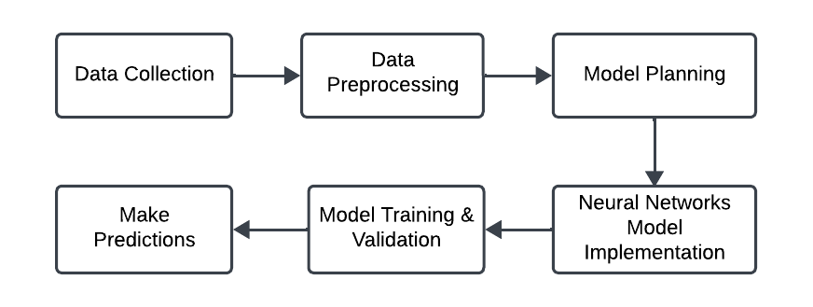

**4.1 Identifying anomalies:**

Identifying anomalies or imperfections in a dataset often involves grappling with various data challenges, and two common issues encountered in this process are the presence of null values and the need for time binning or compression.

**Null Values:**

Null values, or missing data, can significantly impact the integrity and reliability of a dataset. Identifying and handling these null values is a crucial step in the data preprocessing phase. Null values may arise due to a variety of reasons such as sensor malfunction, data transmission errors, or simply the absence of recorded information. To address this, data analysts employ techniques such as imputation, where missing values are estimated or filled in based on the available data. Imputation methods may include mean or median imputation, forward or backward filling, or more sophisticated approaches like machine learning-based imputation.

**Time Binning or Compression:**

In datasets involving time-series information, the temporal granularity of the data might be excessively detailed, leading to challenges in analysis and interpretation. Time binning or compression is a technique used to aggregate or compress time intervals, thereby reducing the volume of data without sacrificing critical information. This process involves grouping data points within specified time intervals and summarizing or averaging them. For instance, if the original dataset records data points every second, binning could be performed to create new data points representing averages over minutes or hours. This not only reduces the dataset's size but also facilitates a more generalized analysis by capturing overarching trends rather than individual data points. Time compression is particularly valuable when working with large-scale datasets, as it improves computational efficiency and helps focus on essential temporal patterns.

**4.2 Data Preprocessing:**

In the obtained dataset the features were not resolved according to the time. The 3 attribute values were mapped unevenly with the time.

We had to resolve the issue by making sure that for a given timestamp, each of the attributes had proper defined values.

**4.3 Architecture:**

The below code snippet shows the procedure followed

**#importing the dataset**

import pandas as pd

df = pd.read_csv("data1.csv")

df2 = pd.read_csv("data2.csv", usecols=cols)

**# Merging the data**

merged_df = df.merge(df2, left_on='Time3', right_on='Time2', how='left')

**# Saving the merged DataFrame to a new CSV file**

merged_df.to_csv('merged_data_n3.csv', index=False)

After combining all the data, we get around 23 lakhs data points which was too large for a machine learning algorithm. So we had to compress the data by taking the average of the values in the time interval of 0.5 ms.

Below is the pseudocode used to compress the data.

**# Define the time intervals**

interval = 0.5 **# Interval duration in milliseconds**

**# Create an empty DataFrame to store the averaged data**

averaged_data = pd.DataFrame(columns=['Time', 'AE Data', 'EC Data', 'Mech Data'])

**# Get the minimum and maximum time values from the dataset**

min_time = 0

max_time = df['Time'].max()

start_time = min_time

end_time = start_time + interval

count = 0

while start_time <= max_time:

mask = (df['Time'] >= start_time) & (df['Time'] <= end_time)

interval_data = df.loc[mask]

**# Saving the averaged data to a new CSV file**

averaged_data.to_csv("averaged_data.csv", index=False)

This is done on all three of the datasets and they are combined together and normalized, making it ready for training the model. A separate column named ‘output’ is created having labels to represent the values of each of the separate datasets.

**#adding the labels**

#combined_df['Output'] = 'label name'

**# Separating the numeric columns from the string column**

numeric_data = data.iloc[:, :4]

string_data = data.iloc[:, 4]

**#Data Normalisation**

from sklearn.preprocessing import MinMaxScaler

scaler = MinMaxScaler()

normalized_numeric_data = scaler.fit_transform(numeric_data)

normalized_df = pd.DataFrame(normalized_numeric_data, columns=numeric_data.columns)

normalized_data = pd.concat([normalized_df, string_data], axis=1)

**Model Planning:**

Considering the size and vastness of our data, we decided to build a neural networks based model. Various such models like ANN and MLP models and even RNN models were taken into consideration.

**Model Implementation & Training:**

We implemented three types of Neural Network models, in search of the best type of approach suitable for our data. Each of the models showed remarkable performance achieving a good accuracy score and making the predictions correctly.

**4.3.1 Multi-Layer Perceptron Model:**

**# Initializing the MLP Parameters**

ann = tf.keras.models.Sequential()

**# Adding the input layer and the hidden layers**

ann.add(tf.keras.layers.Dense(units=32, activation='relu', input_dim=input_dim, kernel_regularizer=regularizers.l2(0.01)))

ann.add(tf.keras.layers.Dense(units=64, activation='relu',

kernel_regularizer=regularizers.l2(0.01)))

ann.add(tf.keras.layers.Dense(units=32, activation='relu', kernel_regularizer=regularizers.l2(0.01)))

ann.add(tf.keras.layers.Dropout(0.5))

**# Adding the output layer**

ann.add(tf.keras.layers.Dense(units=3, activation='softmax'))

**# Defining the hyperparameters**

from tensorflow.keras.utils import to_categorical

y_train_encoded = to_categorical(y_train, num_classes=3)

ann.compile(optimizer='sgd', loss='mse', metrics=['accuracy'])

**#training the model**

history=ann.fit(X_train, y_train_encoded, batch_size = 32, epochs = 100)

from sklearn.metrics import accuracy_score

print(accuracy_score(y_test,y_pred_class))

**4.3.1 Recurrent Neural Networks Model**

**# Defining and Training the RNN model**

from keras.models import Sequential

from keras.layers import SimpleRNN, Dense

model = Sequential()

model.add(SimpleRNN(units=128,activation='relu',input_shape=(X_train_rnn.shape[1], X_train_rnn.shape[2])))

model.add(tf.keras.layers.Dropout(0.5))

model.add(Dense(units=3, activation='softmax'))

**Making Predictions:**

The models were almost able to perform predictions accurately. The models also showed signs of overfitting which needs to be addressed.

test=model.predict(sc.transform(

[[3.5426830286659757e-06,0.24547880116959062,0.3226955560075358]]))

print(test.argmax(axis=1))

**5. RESULT & DISCUSSION**

Out of all the models that were implemented, the MLP model demonstrated exceptional performance, achieving an impressive accuracy of approximately 99.71%. This high level of accuracy indicates the robustness of the neural network in capturing complex patterns within the data.Furthermore, it is noteworthy that the majority of data points were predicted with remarkable accuracy.

The following table highlights the training and testing accuracies obtained in two different cases.

**Case I:** The data used for training and testing the model was divided into 80% and 20% respectively.

**Case II:** The data used for training and testing the model was divided into 70% and 30% respectively.

| **Accuracy(%)** | **Case I** | **Case II** |
| --- | --- | --- |
| **Training** | 99.71% | 99.41% |
| **Testing** | 99.69% | 99.35% |
| **MSE** | 0.0408 | 0.0940 |

In the neural network architecture employed, two hidden layers were implemented, featuring 32 and 64 neurons, respectively. The choice of the stochastic gradient descent (SGD) activation function was made, emphasizing its effectiveness in optimizing model weights through iterative adjustments based on the negative gradient of the loss function. Mean Squared Error (MSE) was employed as the loss function, serving as a measure of the dissimilarity between predicted and actual values, with the network aiming to minimize this discrepancy during training.

For the output layer, the Softmax activation function was utilized, particularly suitable for multi-class classification tasks as it converts raw output scores into probability distributions across different classes. This configuration represents a structured and customizable neural network design tailored to the intricacies of the specific problem at hand, offering a balanced combination of layer sizes, activation functions, and loss metrics to enhance the model's learning capabilities.

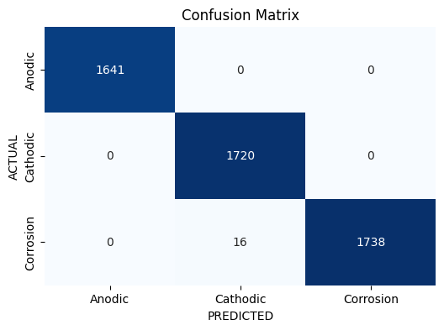

*Fig 7 : Confusion matrix*

The confusion matrix provided indicates the performance of a classification model with three classes: "anodic," "cathodic," and "corrosion." The matrix has three rows and three columns. The diagonal elements represent the true positives, indicating the number of instances correctly

classified for each class. In the "anodic" class, all 1641 instances were correctly classified. Similarly, in the "cathodic" class, all 1720 instances were correctly classified. However, in the "corrosion" class, there were 16 instances that the model failed to identify (false negatives), while the remaining 1738 instances were correctly classified. Notably, there were no false positives for any class, indicating that the model did not mistakenly classify instances of one class as another.

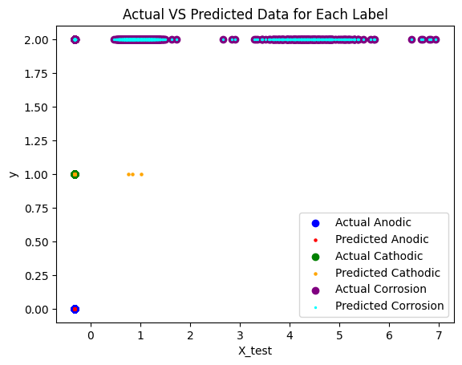

*Fig 8 : Actual vs Predicted Data*

In summary, the model demonstrates strong performance for the "anodic" and "cathodic" classes with no misclassifications. However, in the "corrosion" class, the model had 16 instances where it failed to identify corrosion. Understanding these patterns is crucial for refining the model and addressing its limitations, especially in scenarios where correctly identifying instances of corrosion is of utmost importance.

**6. CONCLUSION & FUTURE ENHANCEMENT**

The use of Acoustic Emissions (A.E) combined with AI and ML techniques holds immense potential for continuous monitoring of hip transplants. By leveraging the power of AI and ML algorithms, healthcare professionals can analyze real-time acoustic emission data to detect potential issues, predict failures, and improve patient outcomes. The objectives outlined, including early detection of complications, minimizing revision surgeries, personalized monitoring, and remote monitoring capabilities, demonstrate the wide range of benefits that can be achieved through this approach.

**Limitations**

Our trained machine learning models exhibit concerning signs of overfitting, indicating that they may have become too tailored to the training data and are struggling to generalize well to new, unseen data. This phenomenon often results in suboptimal performance when applied to different datasets or real-world scenarios. Additionally, we have observed inconsistencies in model performance when various optimizers are employed during the training process.

**Future Enhancements**

Exploring strategies for imputing missing values rather than opting for deletion, aiming to enhance data completeness and build a robust model accordingly. The mentioned limitations underscore the need for a more nuanced approach to model development, potentially involving regularization techniques, increased data diversity and trying out with different versions of the data, or hyperparameter tuning to enhance generalization and robustness across different optimization strategies. Addressing these overfitting issues and optimizer-related challenges is crucial for improving the reliability and effectiveness of our machine learning models in diverse settings.

**REFERENCES**

[1]”Hip implant performance prediction by acoustic emission techniques: a review” by Ampadi R. Remya & B. Vishwash & Christine Lee& P. Srinivasa Pai & Alejandro A. Espinoza Oras2,5 & Didem Ozevin2,5 & Mathew T. Mathew1,2,4,5

[2]”Artifcial intelligence and machine learning as a viable solution for hip implant failure diagnosis-Review of literature and in vitro case study” by Remya Ampadi Ramachandran, Sheng‐Wei Chi, P. Srinivasa Pai, Kharma Foucher, Didem Ozevin, Mathew T. Mathew.

[3] K. P. Iyengar, A. D. Kariya, R. Botchu, V. K. Jain, and R. Vaishya, "Significant capabilities of SMART sensor technology and their applications for Industry 4.0 in trauma and orthopaedics," *IEEE Trans. Biomed. Eng.*, vol. PP, pp. 1-1, 2022.

[4] R. A. Ramachandran, S. W. Chi, P. S. Pai, K. Foucher, D. Ozevin, and M. T. Mathew, "Artificial intelligence and machine learning as a viable solution for hip implant failure diagnosis—Review of literature and in vitro case study," Med. Biol. Eng. Comput., vol. 61, pp. 1239-1255, Jan. 2023.